 

**FPT-APTECH COMPUTER EDUCATION**

eProject Report

**Real Property**

|  |  |
| --- | --- |
| **Team 2** | |
| **Group Member** | Trần Đức Việt (GL) - D00692  Đinh Tuấn Nghĩa - D00712  Đinh Công Quý - D00783  Trần Đức Anh - D00756 |
| **Instructor** | Mr. Nguyễn Tuân |

- Hanoi, 2/7/2020 -

**1. Problem Definition**

The scope of the project is to design and implement an automated institution housekeeping system. This project is very mayor to all real estate departments. The key focus is given on data security, as the project is online and will be transferred in network. The speed and accuracy will be maintained in a proper way.

**2. Development Environment**

**Hardware**

* Pentium IV CPU 1.80 GHz.
* Hard disk requirement: minimum 8 GB.
* 512 Megabytes of Ram or higher.

**Software**

* IntelliJ IDEA 2019.3.1
* MySQL
* Spring Framework
* Thymeleaf
* HTML5 / CSS3/ Javascript
* Google Font / Bootstrap
* AdminLTE

**3. Usecase Diagram**

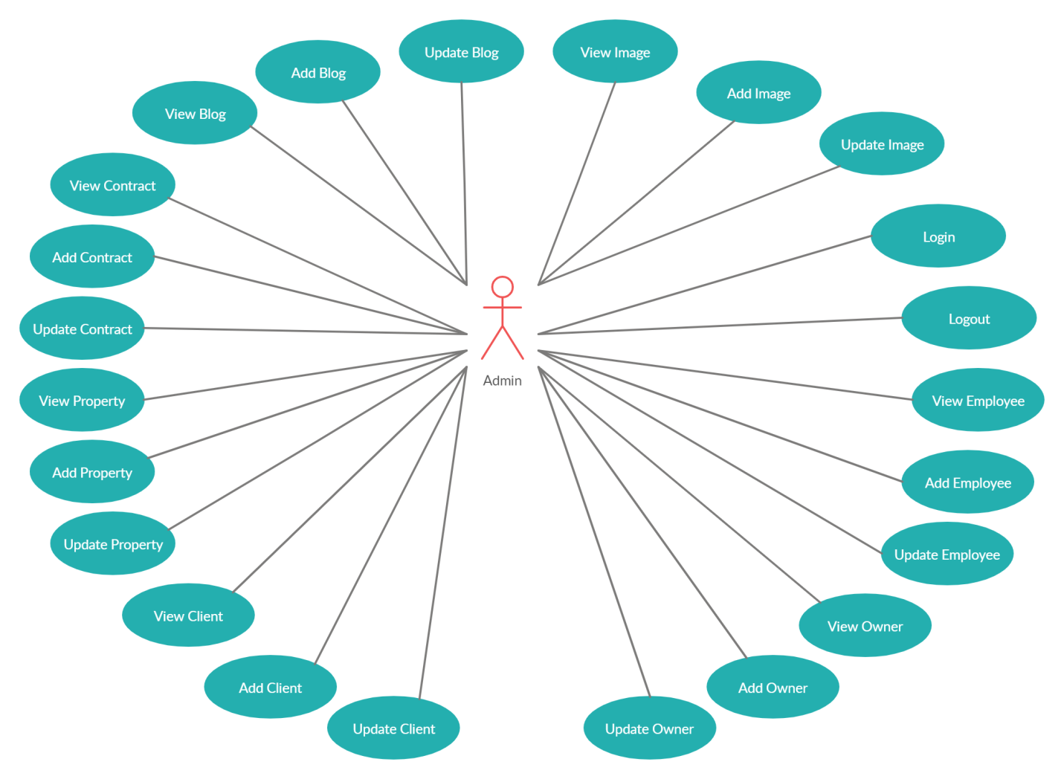

*3.1. Admin Use-case Diagram*

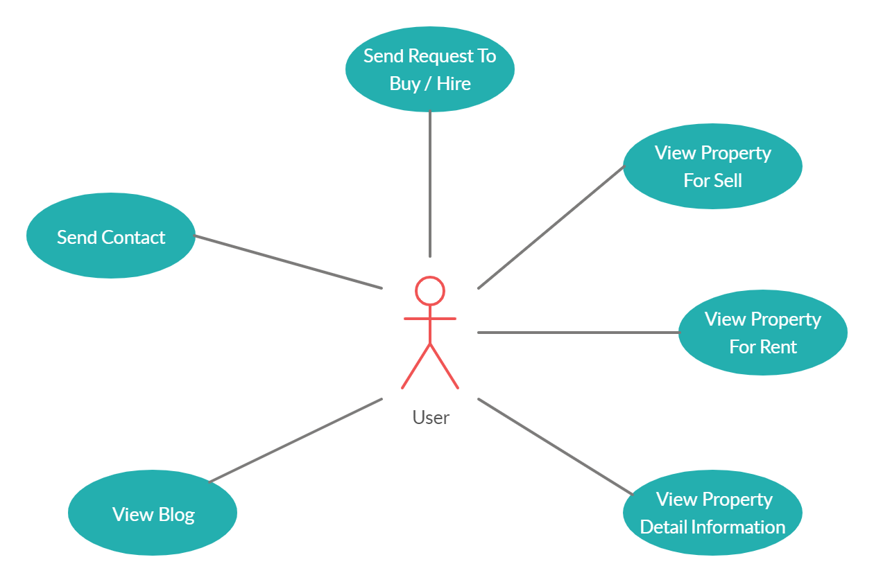

*3.2. User Use-case Diagram*

**4. Database Designer**

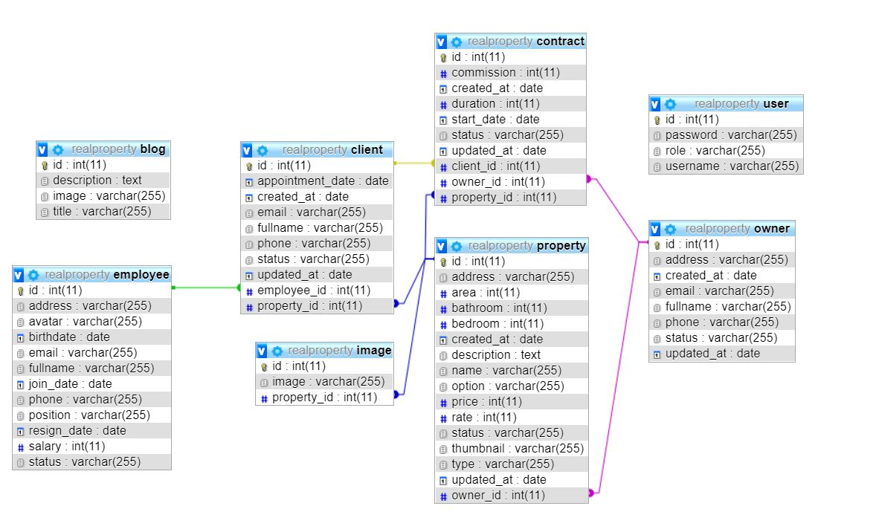

*Database Design*

**5. Class Diagram**

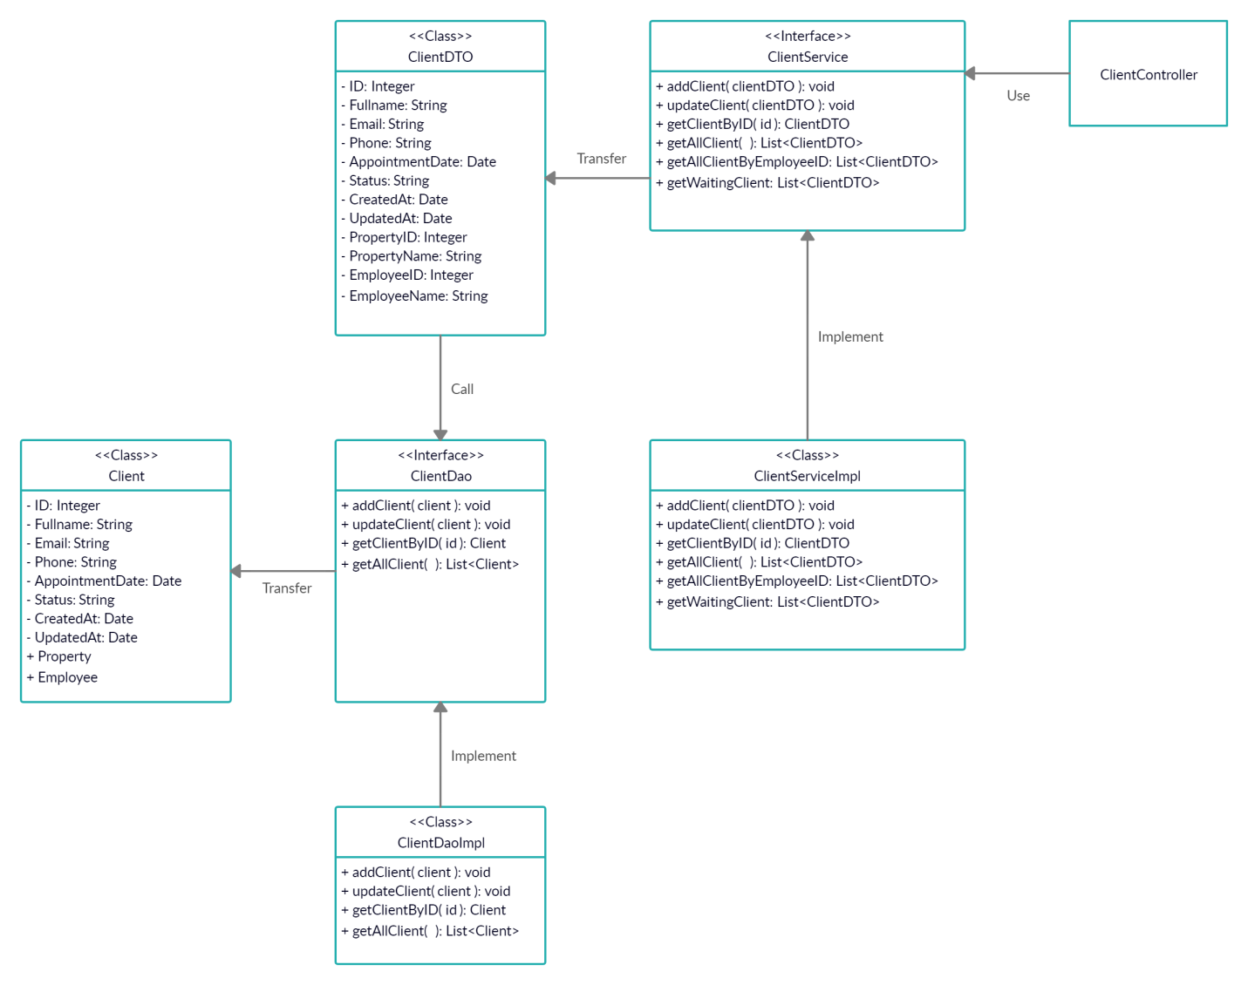

*5.1. Class Diagram Client*

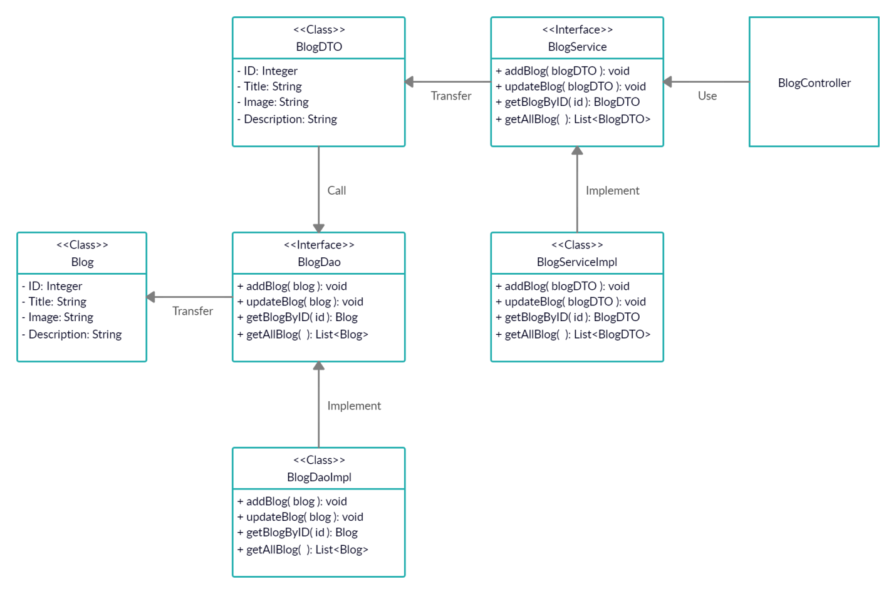

*5.2. Class Diagram Blog*

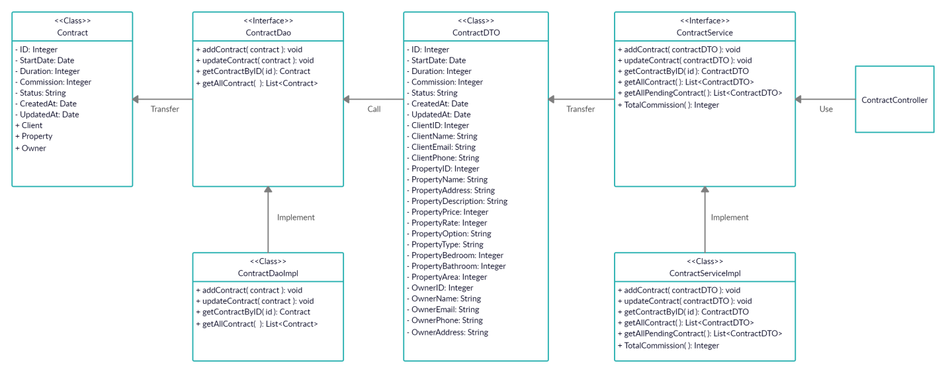

*5.3. Class Diagram Contract*

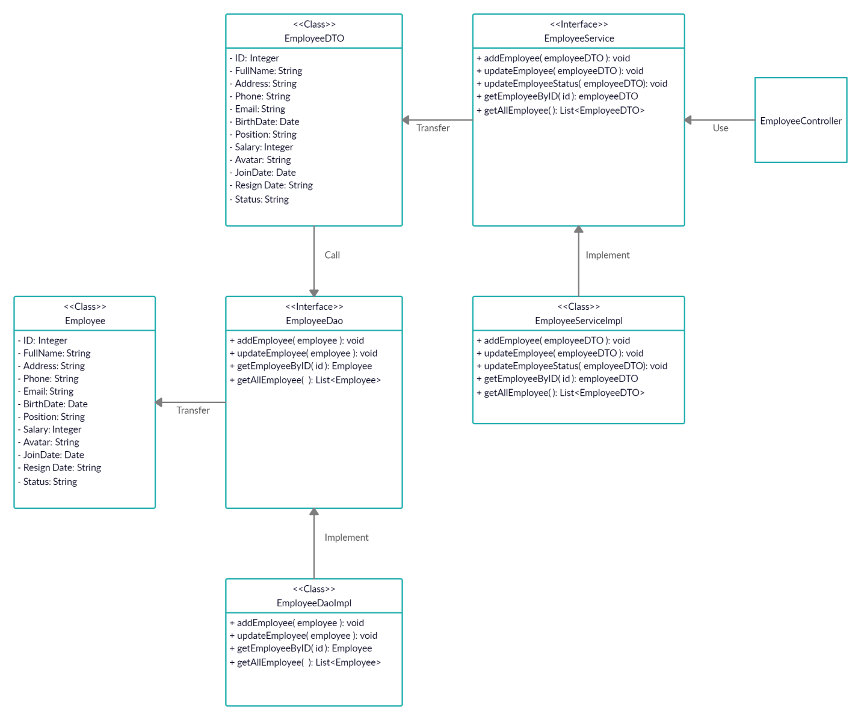

*5.4. Class Diagram Employee*

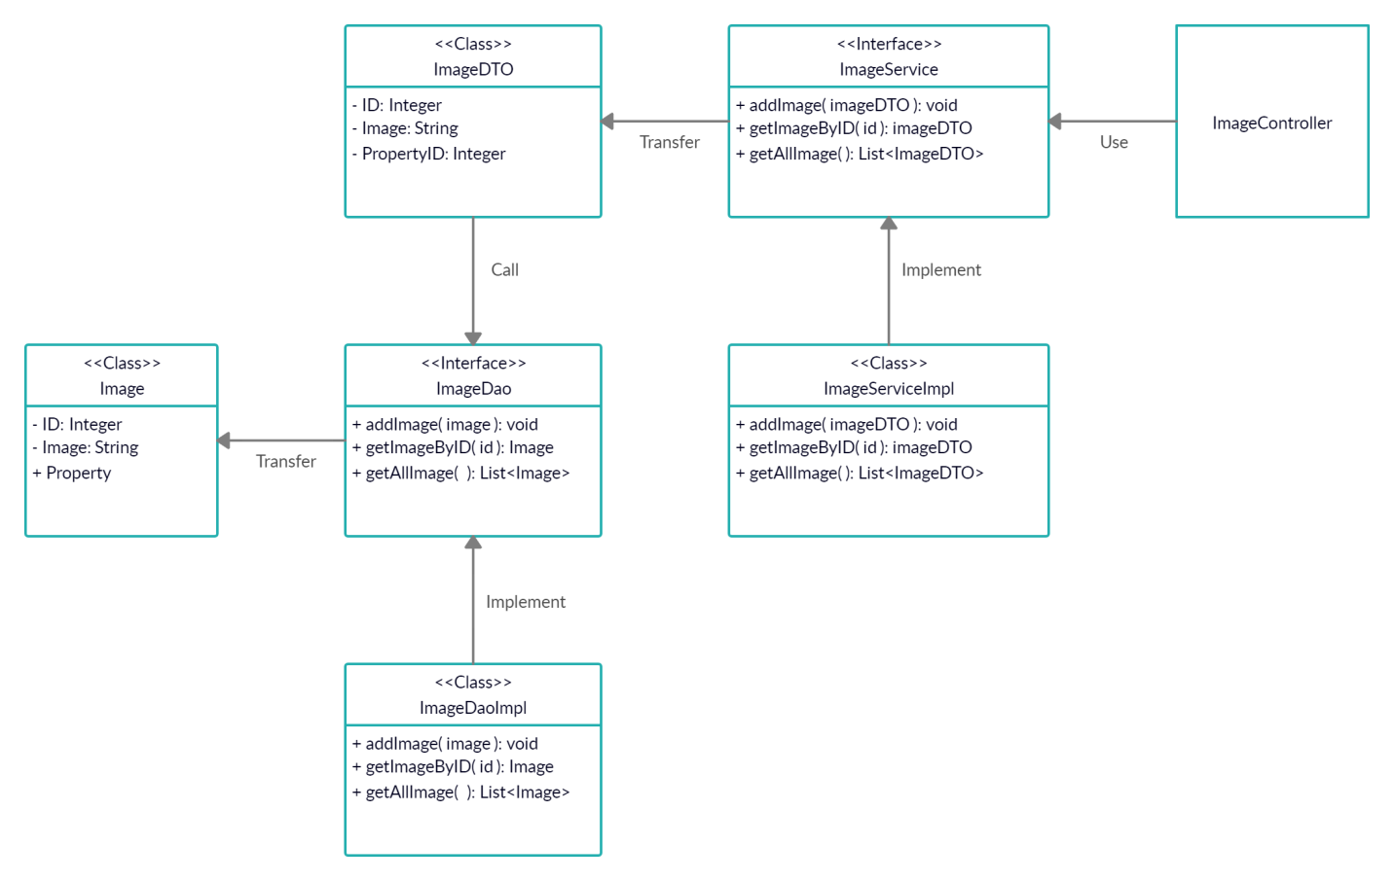

*5.5. Class Diagram Image*

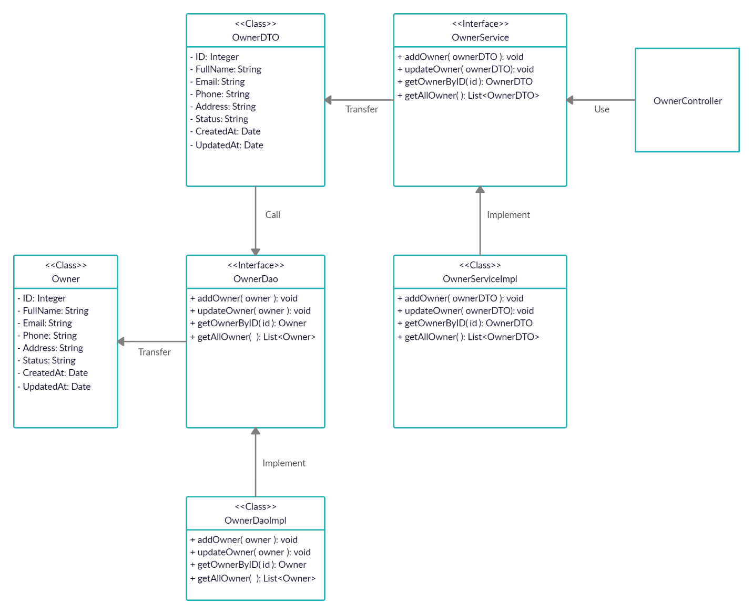

*5.6. Class Diagram Owner*

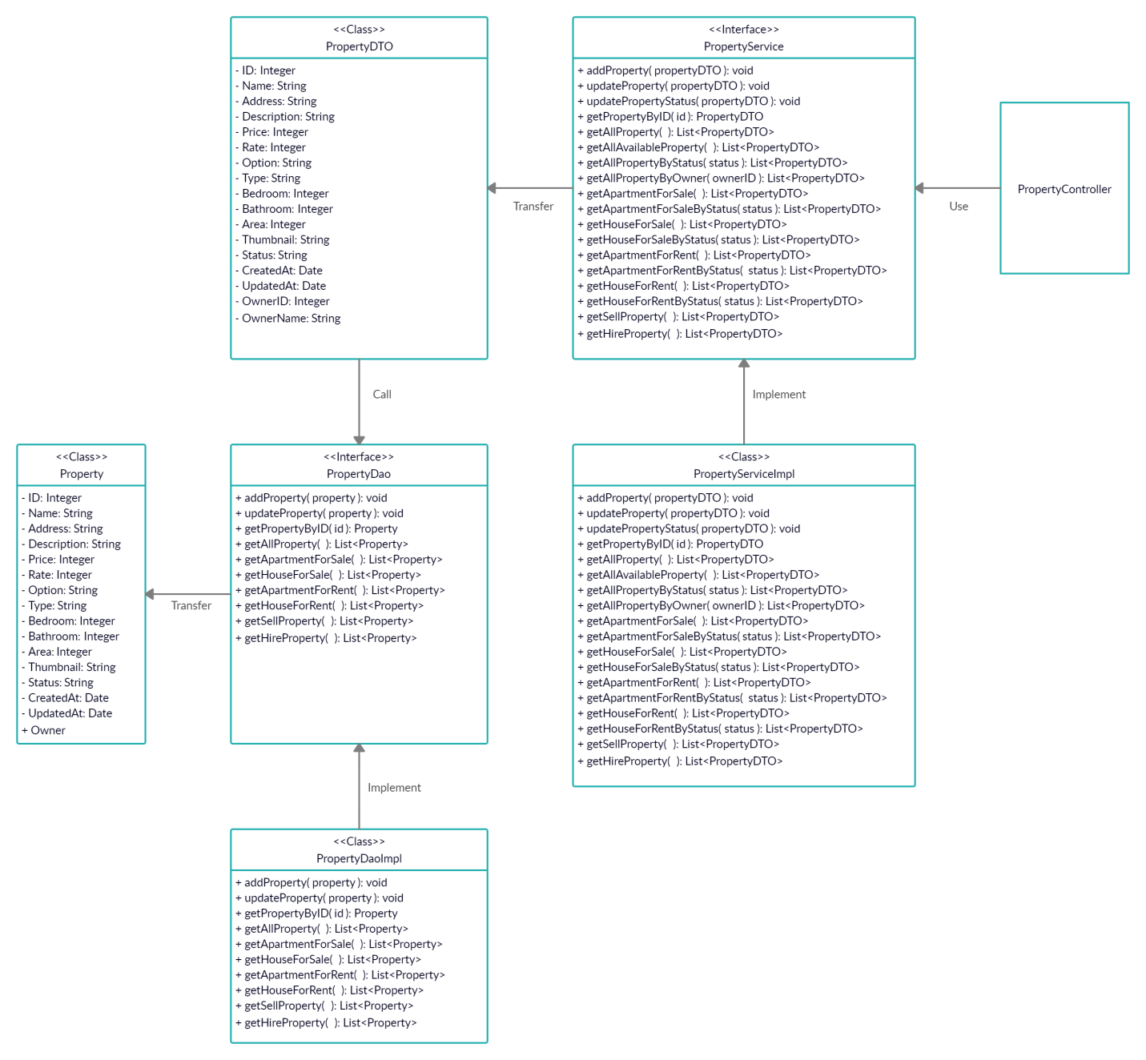

*5.7. Class Diagram Property*

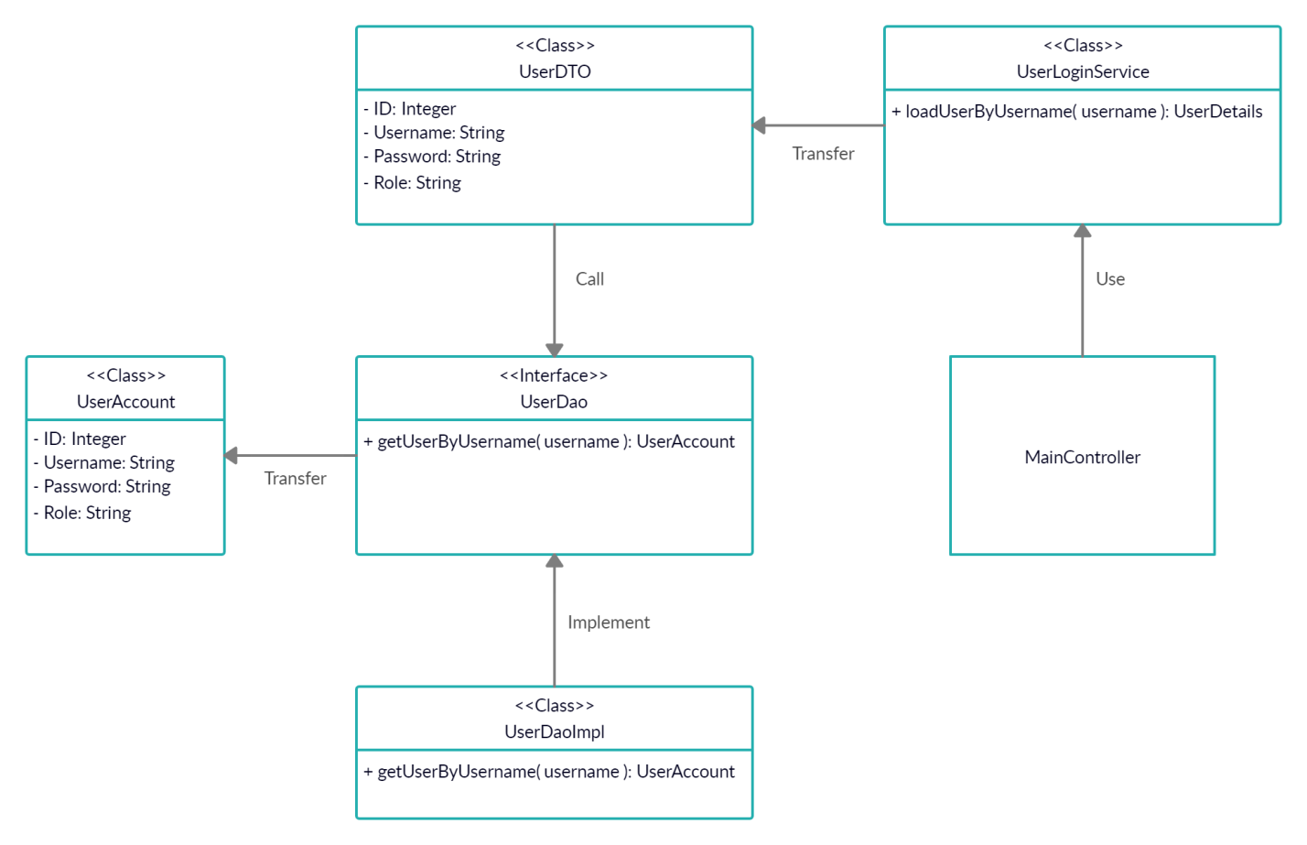

*5.8. Class Diagram Login*

**6. Activity Diagram**

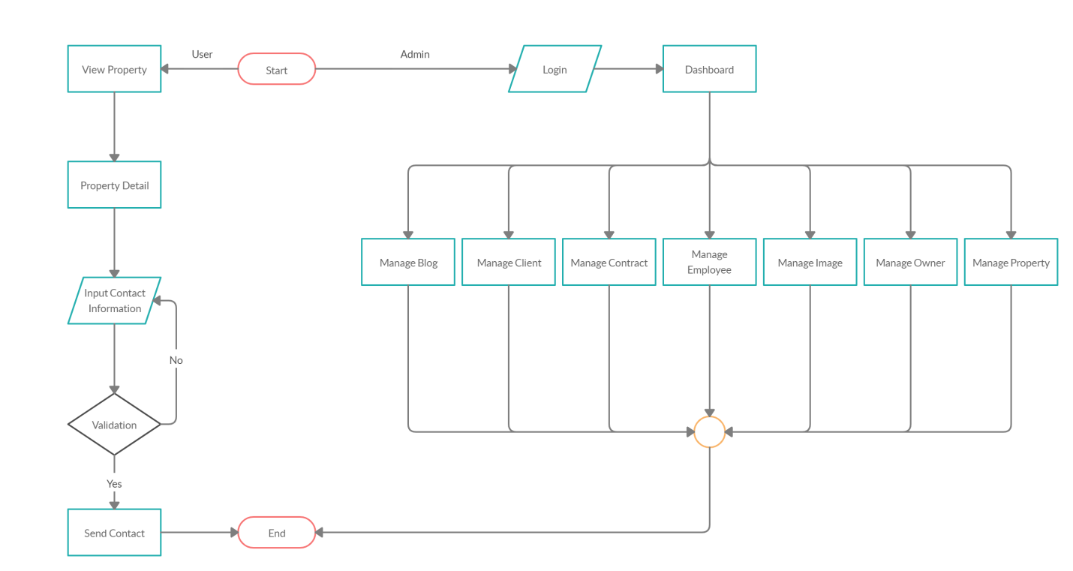

*6.1. Activity Diagram Main*

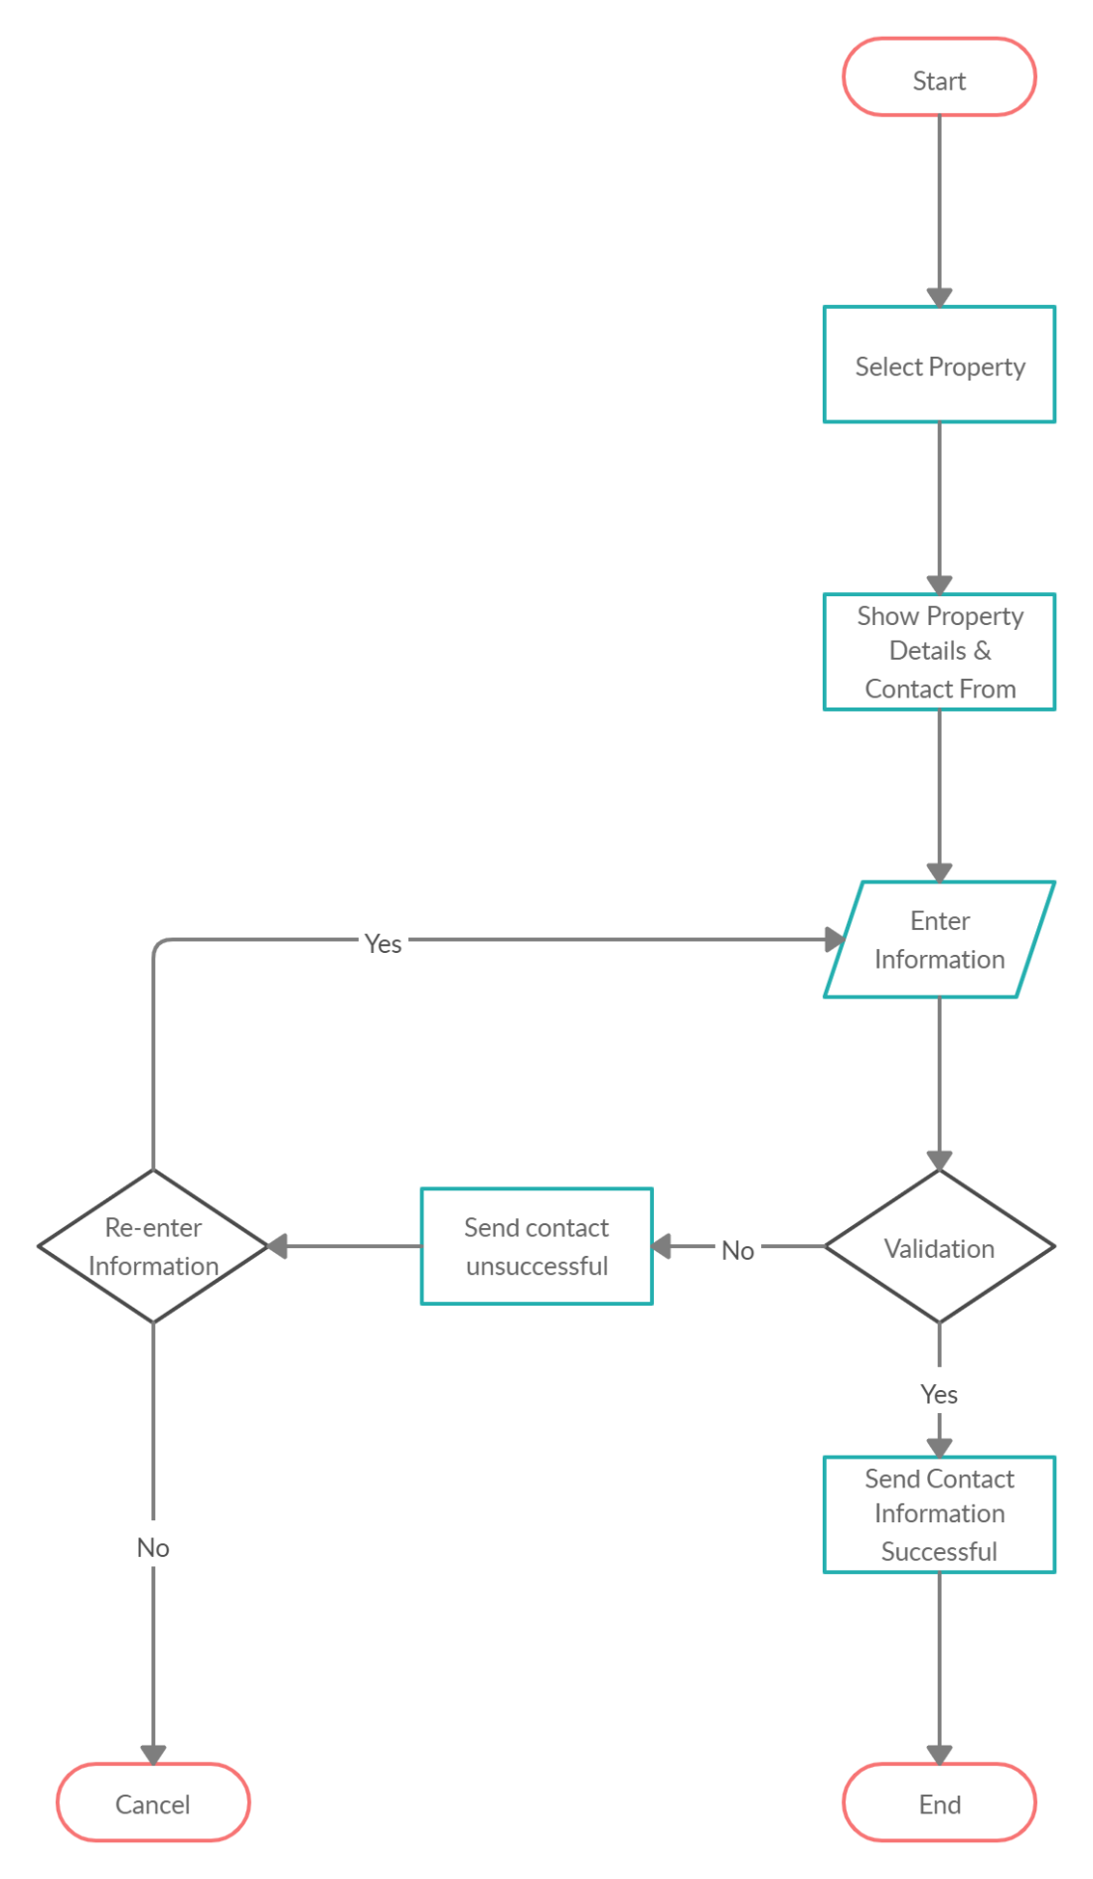

*6.2. Activity Diagram Contact*

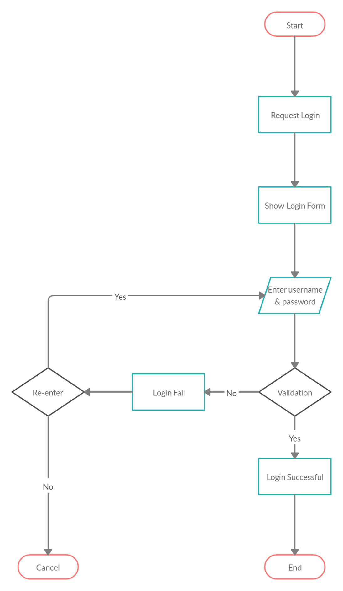

*6.3. Activity Diagram Login*

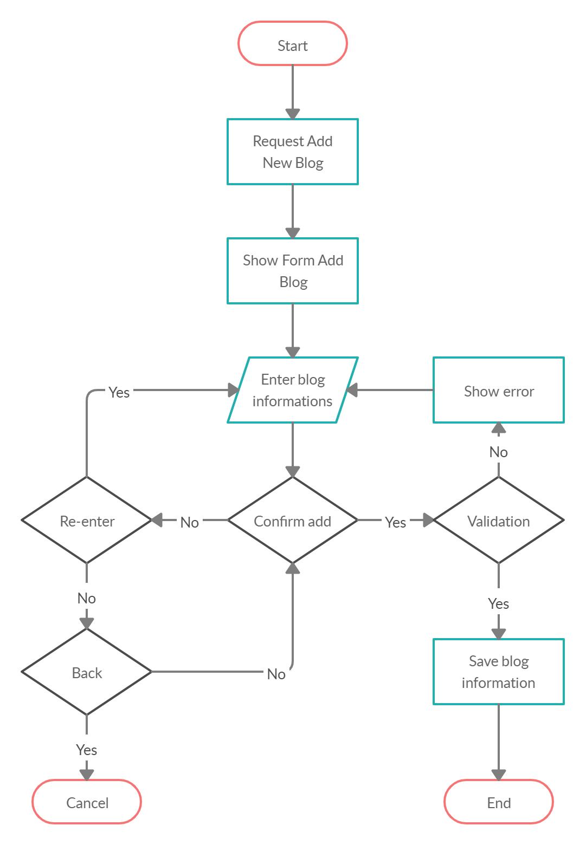

*6.4. Activity Diagram Add Blog*

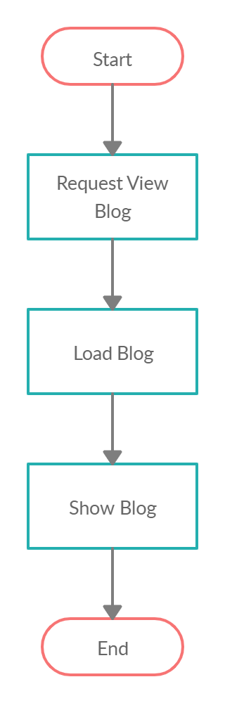

*6.5. Activity Diagram View Blog*

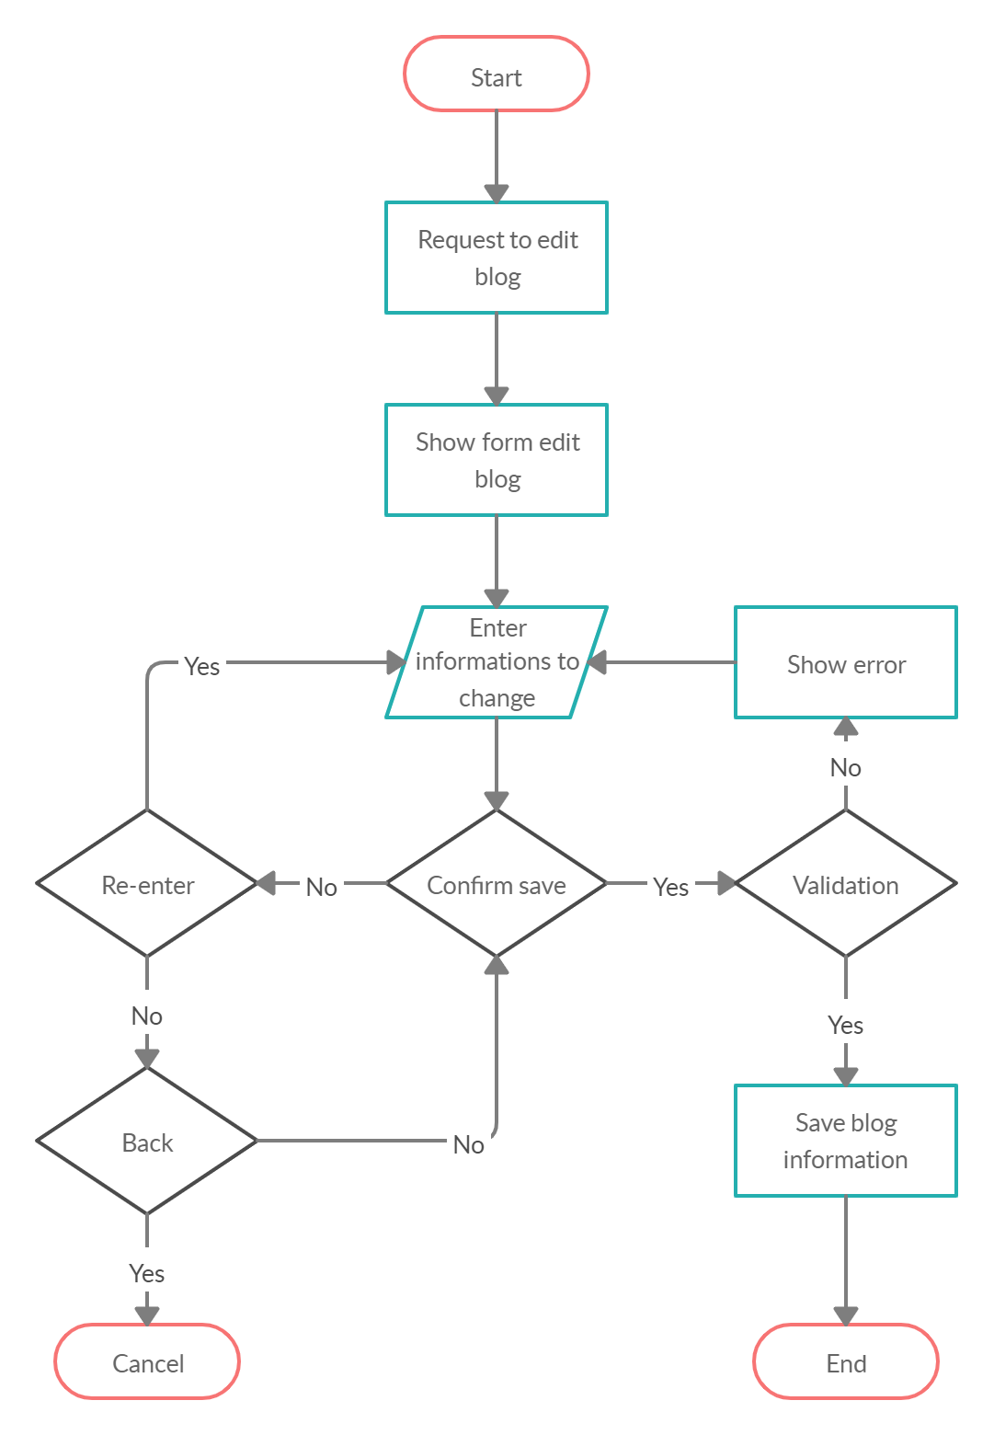

*6.6. Activity Diagram Edit Blog*

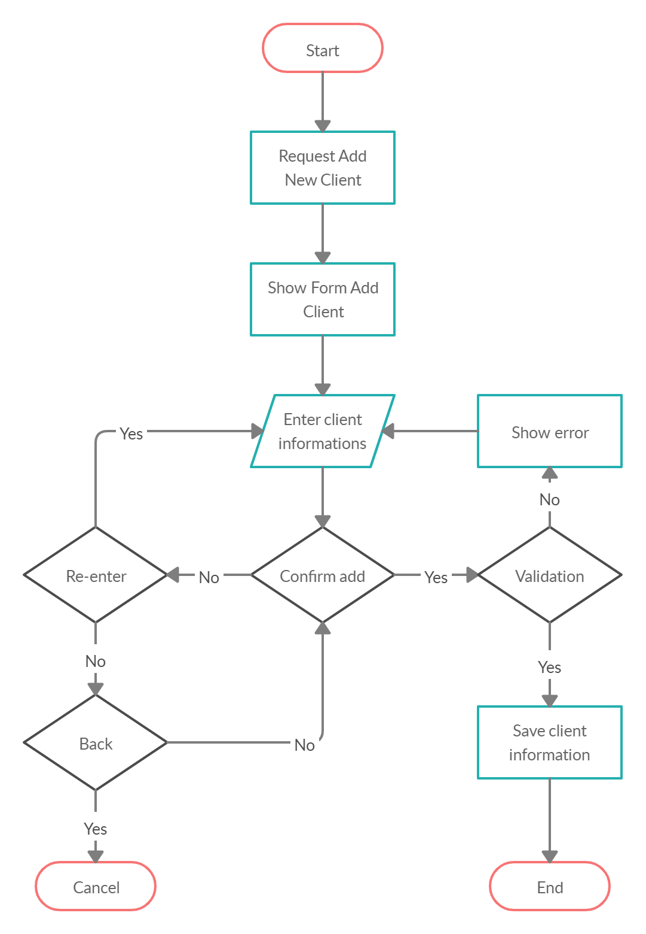

*6.7. Activity Diagram Add Client*

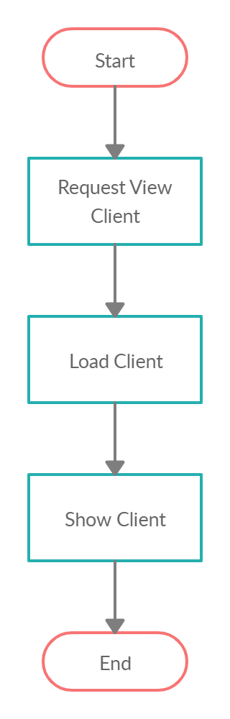

*6.8. Activity Diagram View Client*

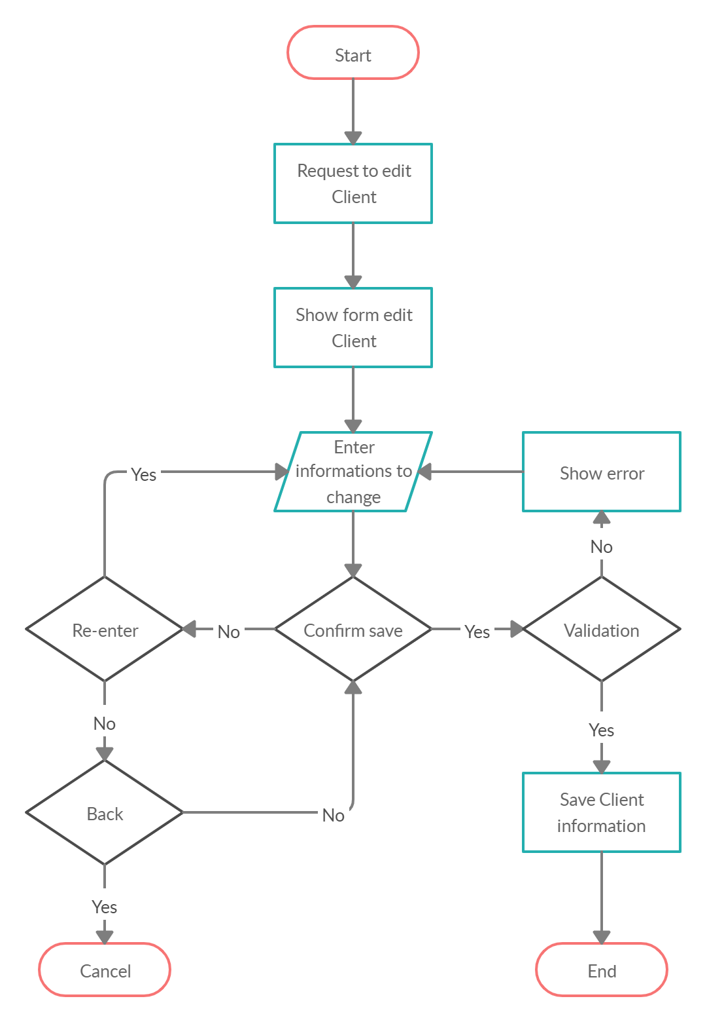

*6.9. Activity Diagram Edit Client*

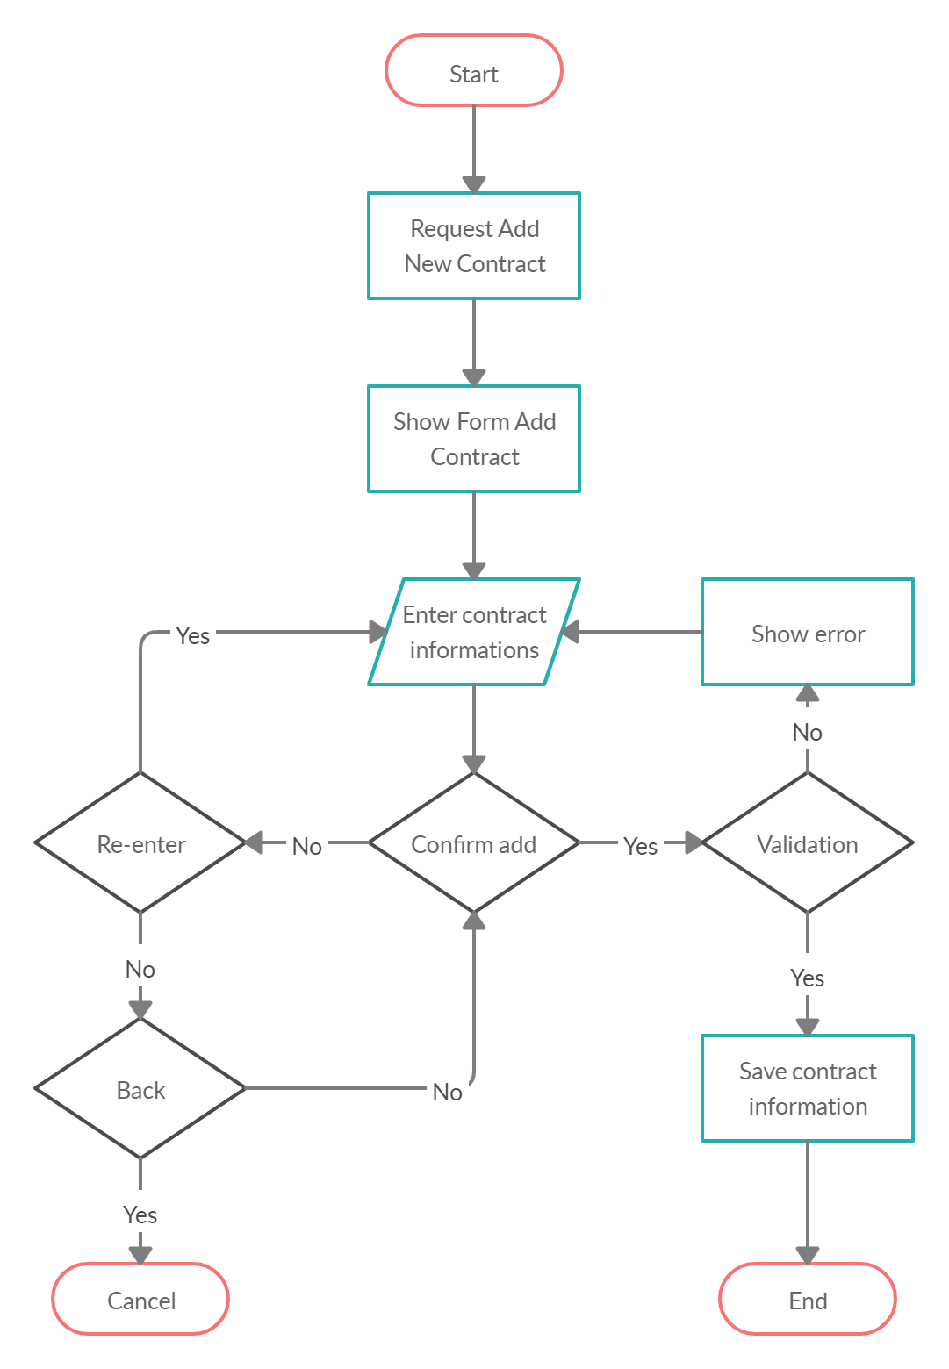

*6.10. Activity Diagram Add Contract*

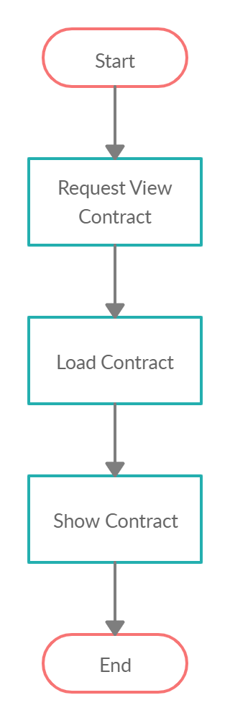

*6.11. Activity Diagram View Contract*

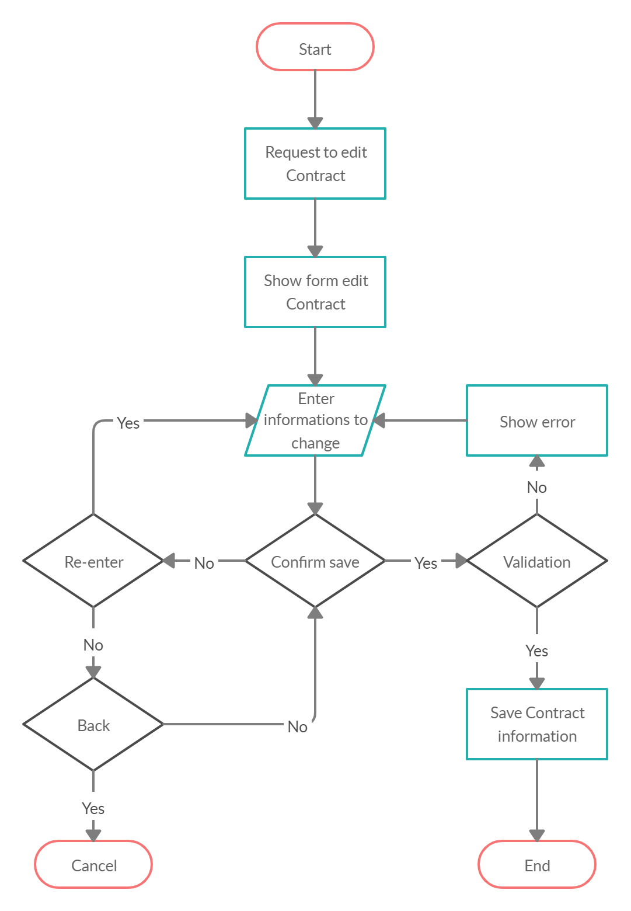

*6.12. Activity Diagram Edit Contract*

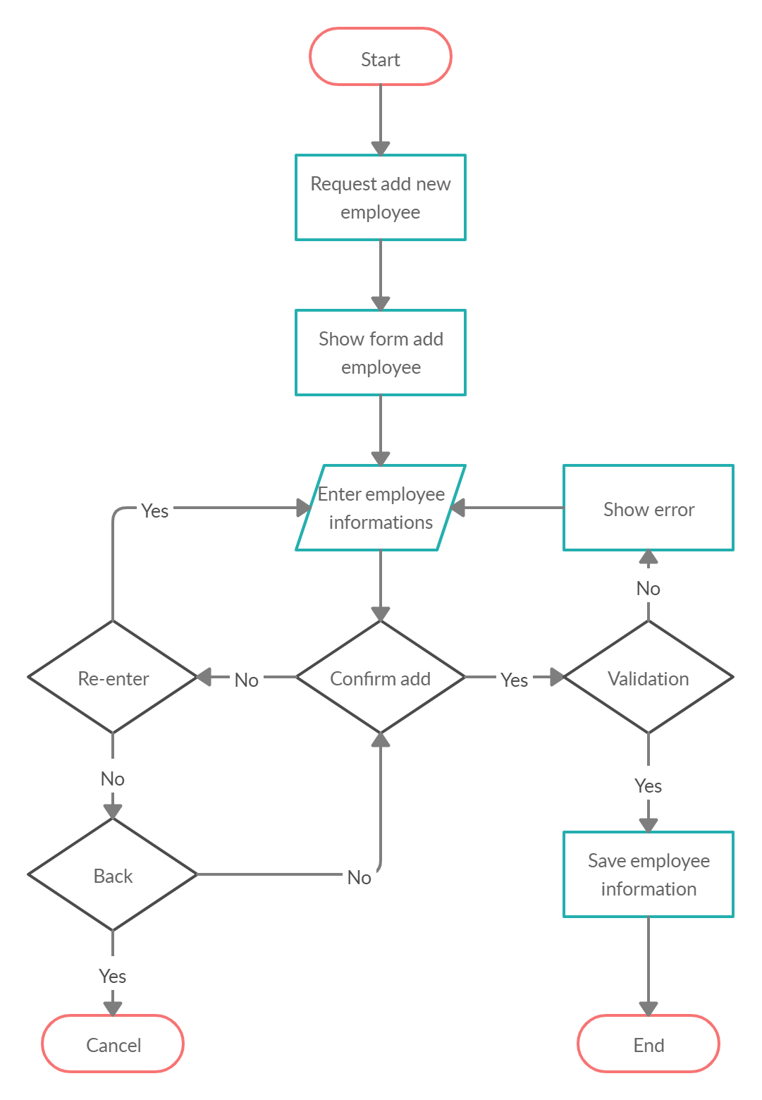

*6.13. Activity Diagram Add Employee*

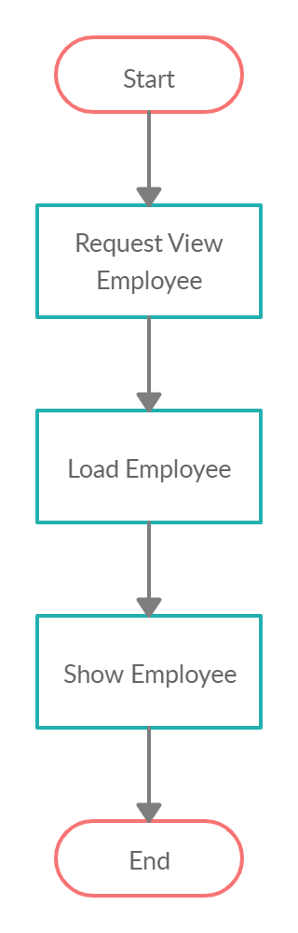

*6.14. Activity Diagram View Employee*

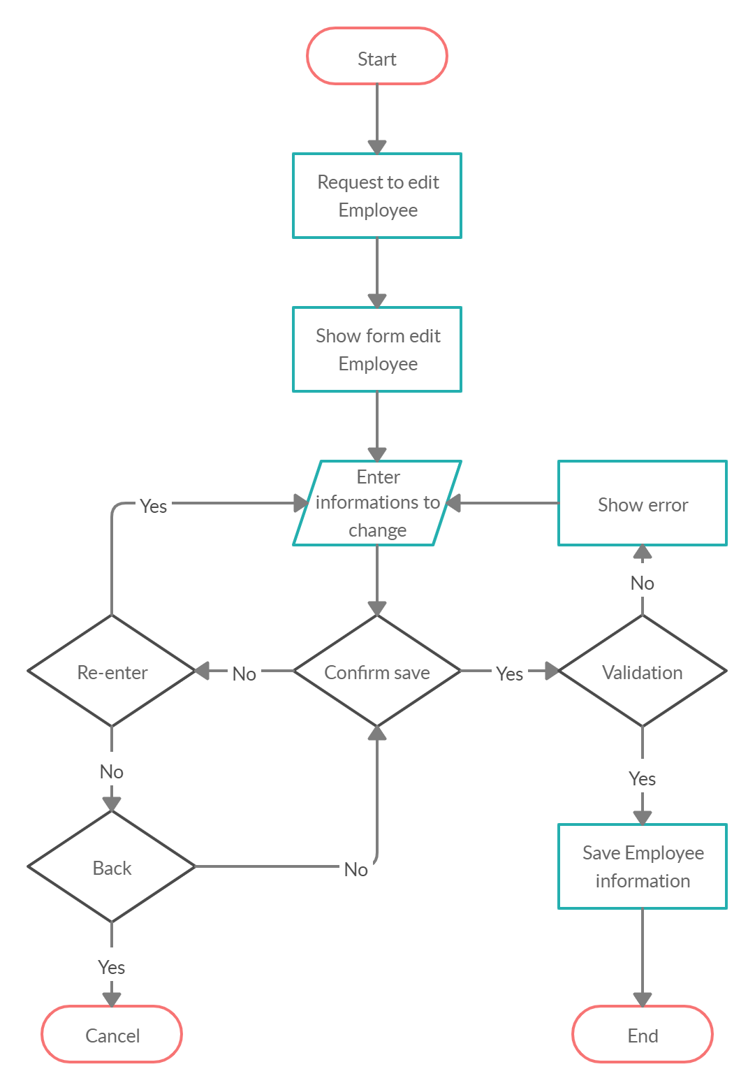

*6.15. Activity Diagram Edit Employee*

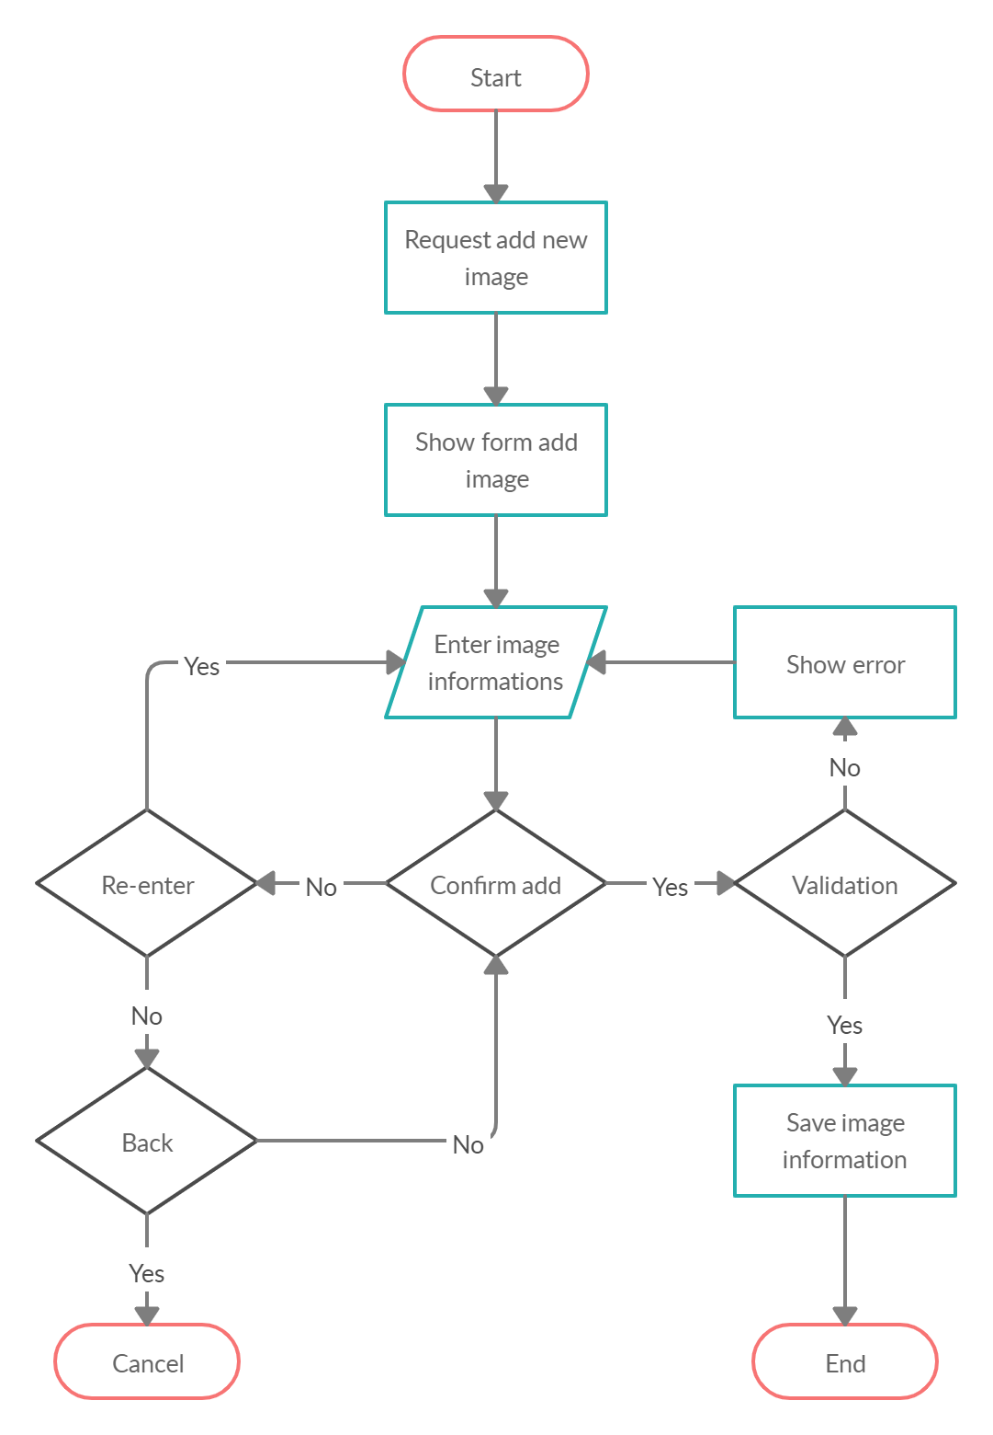

*6.16. Activity Diagram Add Image*

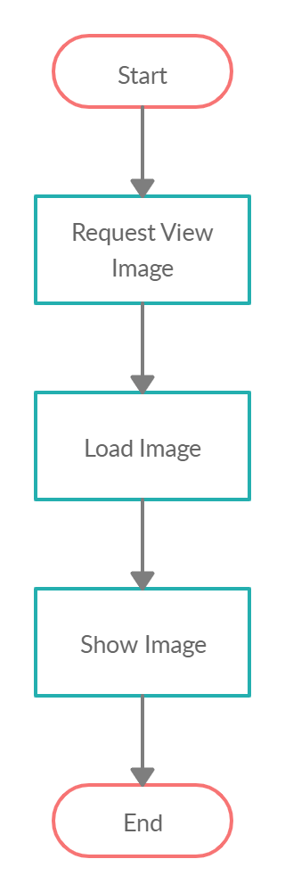

*6.17. Activity Diagram View Image*

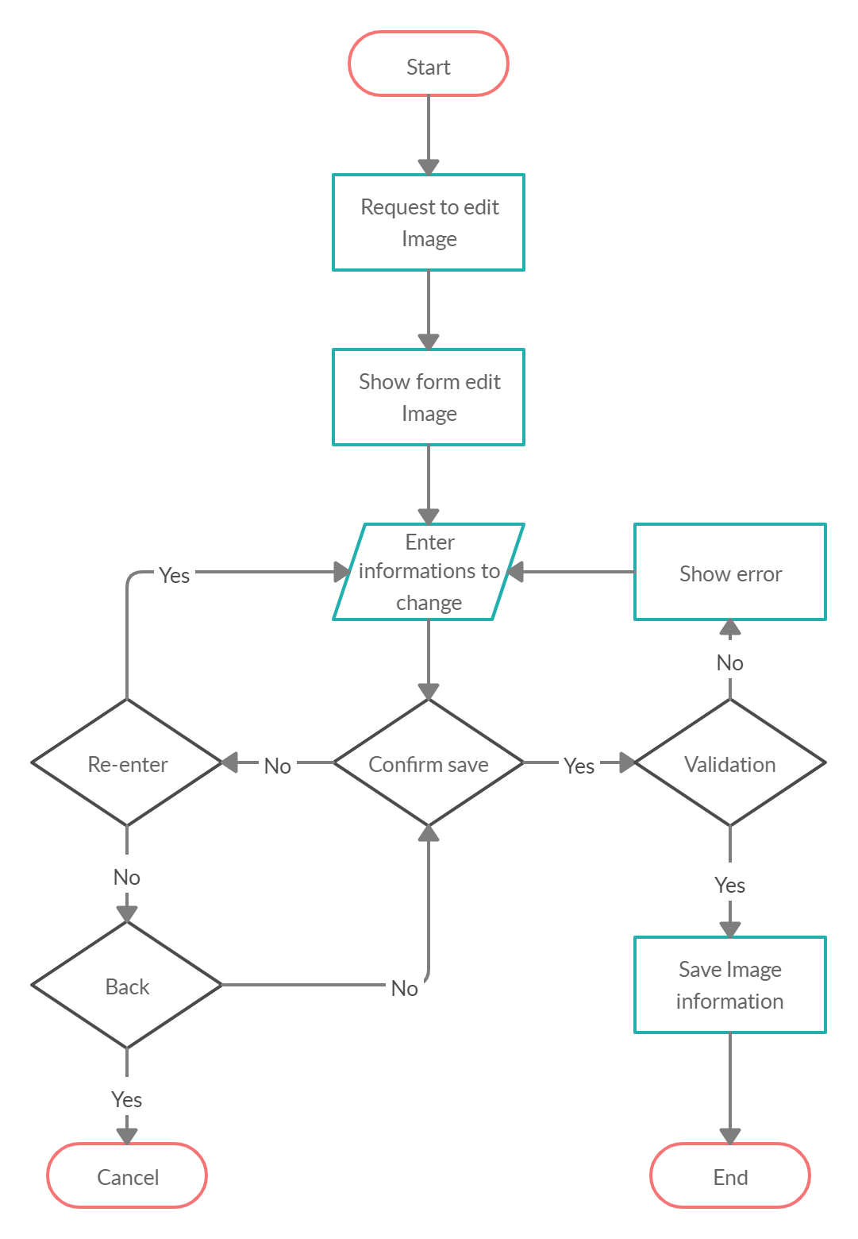

*6.18. Activity Diagram Edit Image*

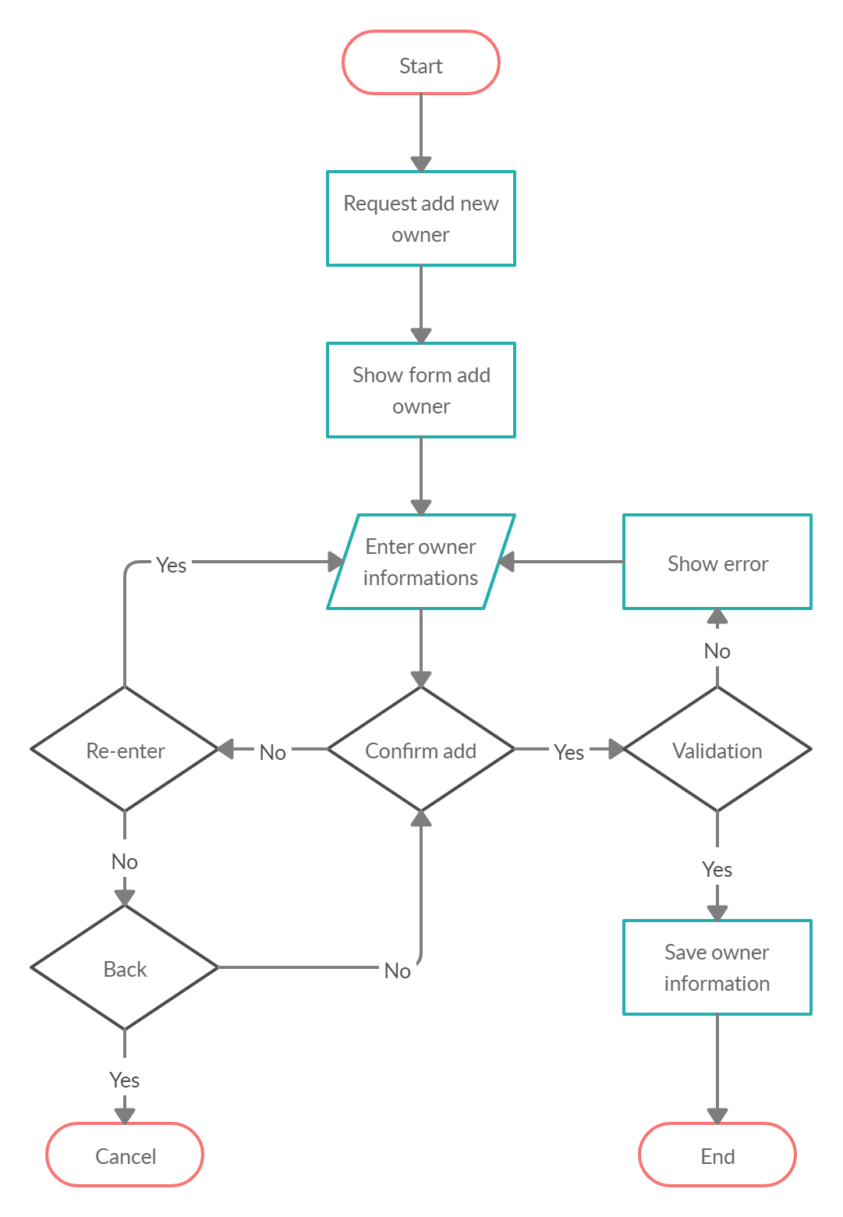

*6.19. Activity Diagram Add Owner*

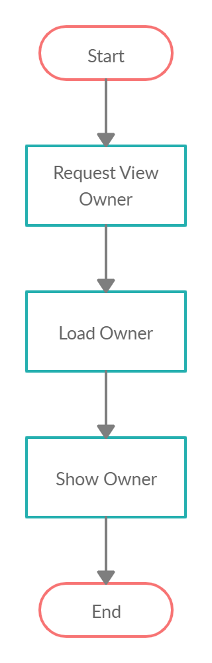

*6.20. Activity Diagram View Owner*

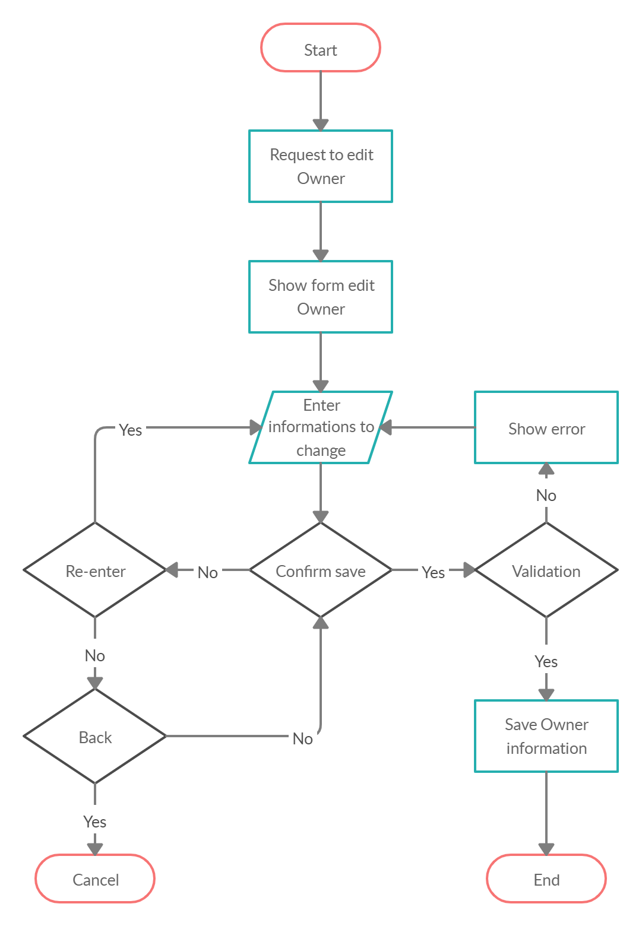

*6.21. Activity Diagram Edit Owner*

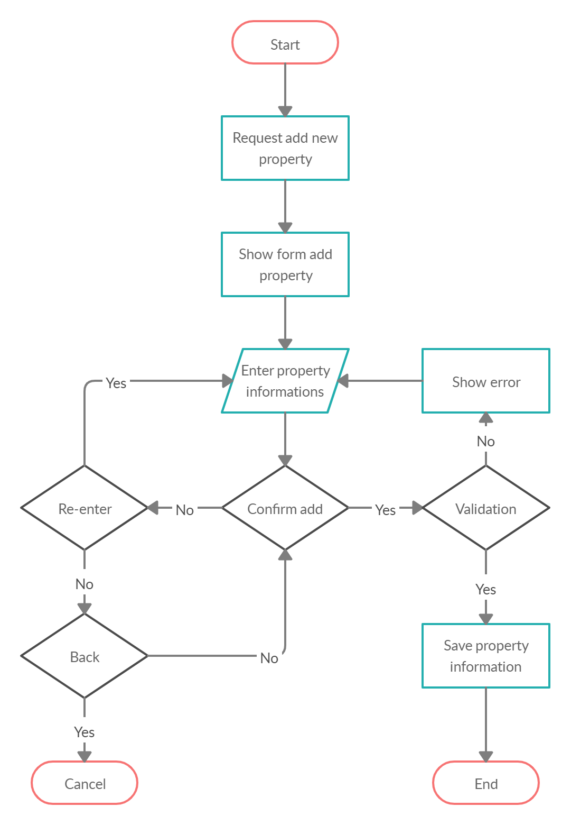

*6.22. Activity Diagram Add Property*

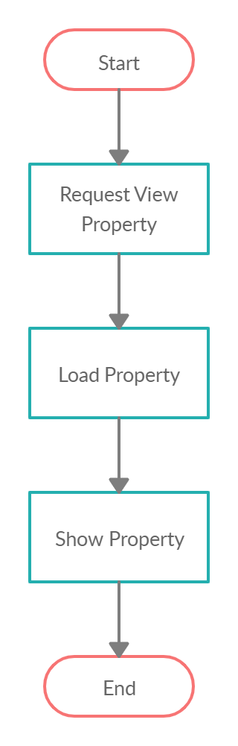

*6.23. Activity Diagram View Property*

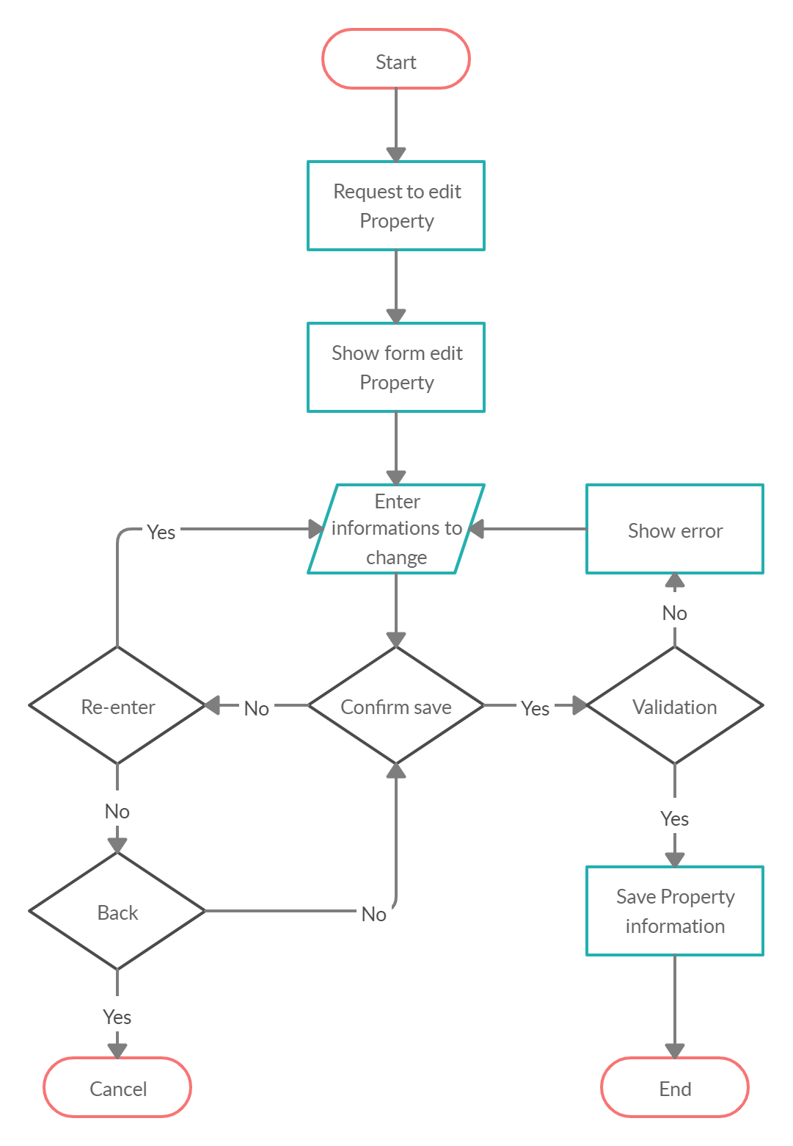

*6.24. Activity Diagram Edit Property*